How College Students Actually Spend Their Meal Plan Dollars
Author: Raghav Krishna
-------------------------------------------------------------------------------------------------------------------------------

Summary of Research Questions and Results
What proportion of meal plan dollars goes toward dining halls versus fast food or retail outlets?
Using the student survey dataset, I analyzed weekly spending patterns and dining behavior indicators such as DHBreakfast and NDHMeals. The results show large variability in weekly spending across students, suggesting that meal plan usage differs widely and that some students supplement dining hall usage with outside purchases.
Do meal plan spending patterns change by student demographics (e.g., year in school, income status)?
Spending patterns were compared across grade levels using boxplots and frequency distributions. The results show that higher grade levels display greater variability in spending, indicating that older students may have more flexible or independent dining habits.
How does national food-away-from-home spending compare with student-reported behavior?
Using USDA Food Expenditure data, I analyzed trends in national spending on food away from home. The analysis shows a steady long-term increase in spending on prepared food purchases, which aligns with the variability seen in student-reported spending patterns.
-------------------------------------------------------------------------------------------------------------------------------

Motivation
Meal plans and college food spending represent a large financial commitment. Students often feel they either overspend early or struggle later in the term. By comparing national food spending data with student survey responses, this project explores whether real spending patterns match student expectations and perceived value.
-------------------------------------------------------------------------------------------------------------------------------

Dataset
USDA Food Expenditure Series (ERS)
Source: https://www.ers.usda.gov/data-products/food-expenditure-series
Due to lack of public access to the originally proposed UNC transaction dataset, I transitioned to the USDA Food Expenditure Series, which provides structured CSV files with national food spending by outlet type.
This dataset tracks national food spending over time, including food-away-from-home purchases. Each row represents a monthly or yearly spending record. Columns include Year, spending totals, and category breakdowns.
The dataset required cleaning because column names were long and values included commas that prevented direct numeric analysis.
Student Food Spending Survey (Kaggle)
Source: https://www.kaggle.com/datasets/mlomuscio/student-food-survey
This dataset contains student responses about dining behavior, weekly spending, grade level, and perception of affordability. Each row represents one student response and helps explain behavior behind the spending patterns.
Average College Student Food Spending
Source: https://educationdata.org/average-monthly-food-spend-college-student
This dataset provides national benchmark statistics on student food spending. It is used as contextual comparison rather than transaction-level analysis.
-------------------------------------------------------------------------------------------------------------------------------

Method
I loaded both datasets using pandas and performed cleaning steps programmatically. For the USDA dataset, I identified relevant columns, removed commas from numbers, converted values to numeric format, and created a Date column from the year and month fields.
For the survey dataset, I standardized column names and created a consistent 'Year in School' field from the original Grade column. After cleaning, I generated summary statistics, checked missing values, and created multiple visualizations to explore patterns. These visualizations include Figures 1–4, which connect cleaned variables directly to the research questions.
-------------------------------------------------------------------------------------------------------------------------------

EDA RESULTS
-------------------------------------------------------------------------------------------------------------------------------

Dataset Size and Structure
Dataset 1 — USDA Food Expenditure Data
This dataset contains national food spending records collected by the USDA.
Rows: 28, Columns: 27
Each row represents one year of food expenditure data.
Columns include multiple categories of food spending, such as:
• Total food-at-home expenditures
• Food sales at full-service restaurants
• Food sales at limited-service restaurants
• Food sales at drinking places
• Food sales at retail stores
During preprocessing, my code extracts and standardizes: Food Away From Home - spending on prepared food and dining locations, Food At Home - grocery-style spending, Year, and a generated Date column. These cleaned variables are used for all analysis and visualizations. Figures 3 and 4 use these cleaned USDA variables to show long-term national trends in food-away-from-home spending.
Dataset 2 — Student Food Spending Survey
This dataset contains survey responses from college students about their dining habits and food spending behavior. It helps explain the “why” behind the trends seen in the USDA spending patterns.
Rows: 167, Columns: 14
Each row represents one student response.
Important variables used in my analysis:
• Grade → renamed to Year in School in code
• Money - weekly spending amount
• DHBreakfast, NDHMeals, DHBoxes - dining behavior indicators
• Nutrition - perception-based measure
This dataset provides behavioral context behind the spending trends seen in the USDA data.
-------------------------------------------------------------------------------------------------------------------------------

Missing Data Analysis
I checked missing values using:
df.isnull().sum()
df.isnull().mean() * 100
This allowed me to examine both total missing values and percentage missingness for each dataset.

Dataset 1 — USDA Food Expenditure Data
• All major spending columns contain 0% missing values
• The Year column is fully complete
• No financial variables required row removal
Because this dataset comes from a structured government source, it was already highly complete. The main preprocessing step involved converting numeric strings with commas into usable numeric values rather than handling missing data.
Handling Approach: No rows were removed. Spending values were converted to numeric format. Date column was generated from the Year field. Since there was no significant missingness, the dataset could be used directly after cleaning.

Dataset 2 — Student Food Spending Survey
• Grade → 1 missing value (~0.6%)
• Athlete → 1 missing value (~0.6%)
• Activities → 1 missing value (~0.6%)
• DHBoxes → 2 missing values (~1.2%)
• NDHBoxes → 3 missing values (~1.8%)
• Nutrition → 1 missing value (~0.6%)
• Money → 26 missing values (~15.6%)
The Money column has the largest amount of missing data, which is expected because survey respondents sometimes skip financial questions.
Handling Approach:
• Behavioral categorical variables were kept as-is since missingness was minimal
• The Money column was converted to numeric values using pd.to_numeric(errors="coerce")
• Rows with missing Money values were excluded only from boxplot visualizations, not from the entire dataset
This approach preserves as much survey information as possible while ensuring accurate statistical summaries.
-------------------------------------------------------------------------------------------------------------------------------

Variables of Interest
My analysis focuses on variables that directly connect spending trends with student behavior.
From USDA Dataset (after cleaning)
• Food Away From Home: Represents restaurant-style spending. Acts as a proxy for dining hall or campus food usage.
• Food At Home: Represents grocery-style spending and provides a comparison baseline.
• Year / Date: Used to examine long-term spending trends over time.
These fields are created programmatically in clean_usda() inside mealplan_analysis.py.
From Survey Dataset
• Year in School (derived from Grade): Used to compare behavior across student groups.
• Money: Numeric weekly spending variable used in boxplots.
• Dining Behavior Columns (DHBreakfast, NDHMeals, DHBoxes): Provide insight into how often students rely on dining services.
These variables align exactly with the columns referenced in the code’s visualization functions.
The survey spending variable (Money) is visualized in Figure 1, which shows how weekly spending varies across grade levels. The distribution of survey responses by class year is also shown in Figure 2 to provide context for how representative each group is within the dataset.
-------------------------------------------------------------------------------------------------------------------------------

Summary Statistics
Quantitative Variables — USDA Spending
Summary statistics are generated using:
df.describe()
Food Away From Home spending shows gradual increases across years, reflecting rising reliance on prepared food purchases. Food At Home spending remains comparatively stable, providing a useful baseline for comparison.
Quantitative Variables — Survey Spending (Money)
• Mean and median values show moderate weekly spending.
• Wide range indicates strong variation in student behavior.
This variation becomes clearer in Figure 1, where several higher-value outliers appear among upper grade levels. This variability supports the idea that meal plan usage differs significantly between individuals.
Categorical Variable — Year in School
Derived from the original Grade column.
Unique values include: 9th, 10th, 11th, 12th
Figure 2 visualizes how frequently each grade level appears in the dataset, which helps interpret later comparisons. These categories are used directly in the bar chart visualization produced by the analysis script. -------------------------------------------------------------------------------------------------------------------------------
Figure 1
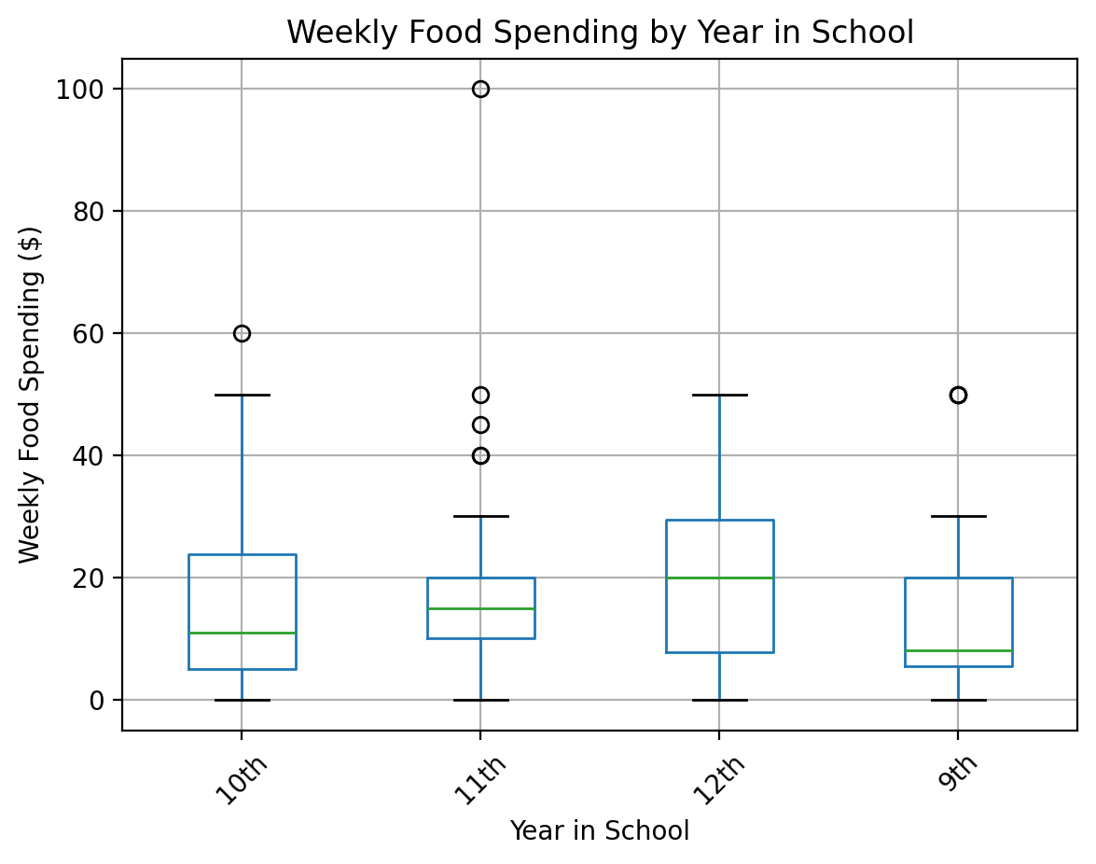
X-axis: Year in School
Y-axis: Weekly Food Spending ($)
Caption: Distribution of weekly food spending grouped by student year in school.

Explanation:
This boxplot shows the distribution of weekly spending (Money) grouped by Grade from the student food survey dataset. I chose a boxplot because it clearly displays medians, spread, and outliers across groups, which helps compare behavior between class levels. The plot was produced using matplotlib after grouping survey responses by year in school. The main takeaway is that spending is not uniform across grades. Some upper-year students report much higher spending, suggesting differences in independence or dining habits as students progress through school.
Figure 2
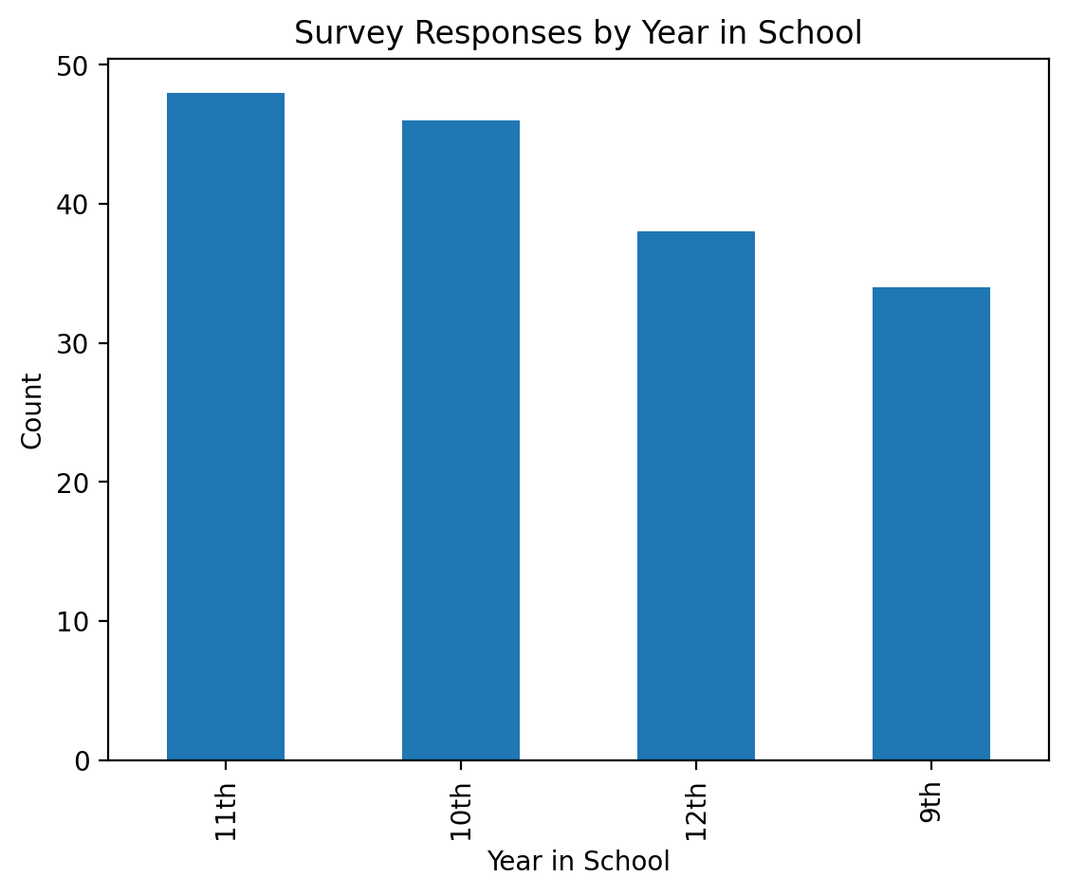
X-axis: Year in School
Y-axis: Count of Responses
Caption:
Number of survey responses by student grade level.
Explanation:
This bar chart shows how many survey responses came from each grade level. I chose a bar chart because the variable is categorical and I wanted to visualize representation across groups. The visualization was generated using value counts on the Grade column. This plot is important because it provides context for later comparisons. Since some grade levels have more responses than others, differences in behavior should be interpreted with that imbalance in mind.
Figure 3
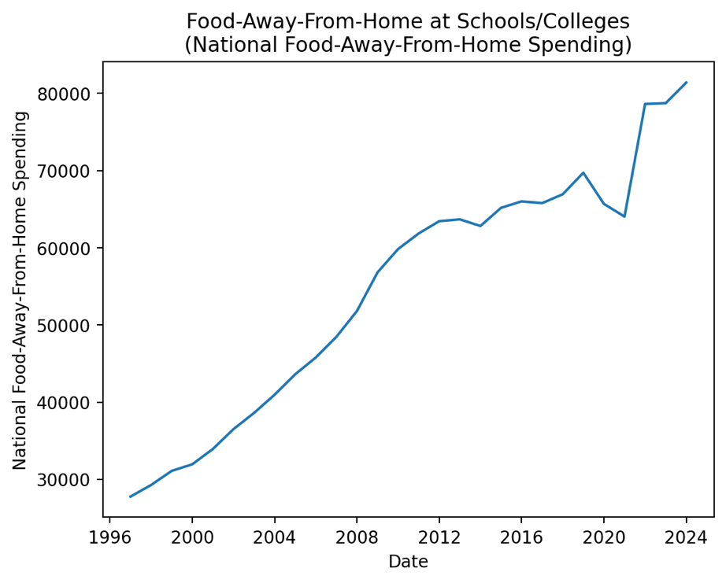
X-axis: Date
Y-axis: National Food-Away-From-Home Spending
Caption:
National spending on food away from home over time based on USDA food expenditure data.
Explanation:
This line plot shows national spending on food away from home using the USDA Food Expenditure Series dataset. The visualization was generated after cleaning numeric values and creating a Date column from the year field. A line chart was used because the data represents a time series, making it easier to observe changes in spending over time.

Figure 4
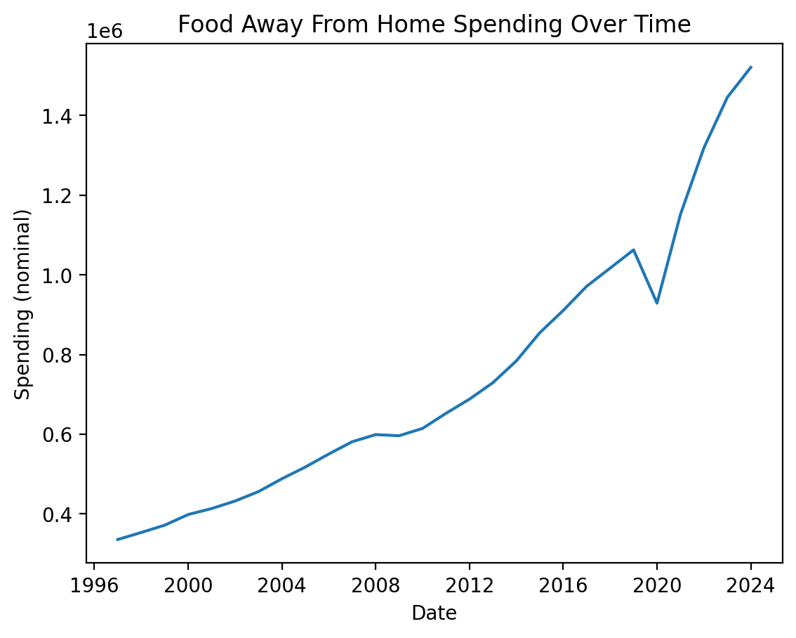
X-axis: Date
Y-axis: Spending (nominal)
Caption: Share of food-away-from-home spending occurring at schools and colleges over time.
Explanation:
This line chart displays nominal spending on Food Away From Home from the USDA dataset. I chose this visualization because it highlights long-term financial trends and helps compare national behavior with survey-based student patterns. The chart was generated after cleaning messy column names and converting values that originally contained commas into numeric format. The upward trend suggests that prepared food spending has become more common nationally, which supports the idea that dining plans and campus food systems reflect broader economic trends rather than isolated student behavior.
-------------------------------------------------------------------------------------------------------------------------------

Multiple Dataset Relationship Summary
The two datasets support different parts of the same question.
The USDA dataset shows real national spending trends over time, especially food spending away from home versus food at home. This gives a baseline for how people typically use money on prepared food.
The student food survey dataset focuses on individual behavior and perception. It includes variables like Grade (converted to Year in School), weekly spending (Money), and dining behavior indicators such as DHBreakfast, NDHMeals, and DHBoxes.
Instead of merging individual rows, I compare patterns across both datasets. For example:
• Food Away From Home trends in USDA data compared with student dining behavior indicators
• National spending trends compared with student-reported weekly spending
• Year in school compared with survey behavior patterns
Using both datasets together strengthens the analysis because one shows large-scale financial trends while the other explains student decision-making. Figures 3 and 4 provide the national spending context, while Figures 1 and 2 illustrate student-level behavior and representation within the survey dataset.

Exploratory Data Analysis (EDA)
During exploratory data analysis, I focused on understanding the structure and quality of both datasets before performing any analysis. I first examined the size and structure of each dataset to understand what variables were available and how they could be used to answer the research questions. The USDA Food Expenditure dataset contains yearly national spending records across multiple food categories, while the student food survey dataset contains individual responses about dining behavior and weekly spending.
I then checked for missing values and data formatting issues. The USDA dataset was largely complete, but several numeric columns contained commas and were stored as strings. These values needed to be cleaned and converted to numeric format before analysis. In the survey dataset, most variables had very few missing values, but the weekly spending variable contained a noticeable amount of missing responses. Instead of removing those rows entirely, I excluded them only when generating visualizations that required numeric spending data.
Next, I examined the main variables used in the analysis. From the USDA dataset, I focused on the Food Away From Home and Food At Home spending variables to compare national food spending patterns over time. From the survey dataset, I focused on Year in School and Money (weekly spending) to understand how student food spending behavior varies across groups.
Summary statistics and visualizations helped reveal several important patterns. The survey data showed a wide range of weekly spending values, suggesting that students use meal plans and food purchasing options very differently. At the national level, the USDA data showed that spending on food away from home has increased steadily over time.
Overall, the EDA helped identify which variables were most useful for the analysis, revealed potential issues with missing or formatted data, and guided the choice of visualizations used to explore spending patterns in both datasets.

Results

Research Question 1
What proportion of meal plan dollars goes toward dining halls versus fast food or retail outlets? The student survey data shows significant variation in weekly food spending among students. As shown in Figure 1, spending distributions vary widely across grade levels, with some students reporting substantially higher weekly spending. These differences suggest that some students rely more heavily on food purchases outside of traditional dining halls.

Research Question 2
Do meal plan spending patterns change by student demographics? Differences across grade levels appear in both the distribution of responses and spending variability. Figure 2 shows the number of survey responses across grade levels. While the dataset contains slightly more responses from 10th and 11th grade students, the spending variability shown in Figure 1 suggests that older students may exhibit greater independence in food purchasing decisions.

Research Question 3
How does national food-away-from-home spending compare with student-reported behavior? National spending patterns from the USDA dataset show a steady increase in food-away-from-home spending over time. Figures 3 and 4 illustrate these long-term trends. This suggests that the variability seen in student spending behavior may reflect broader national shifts toward prepared food consumption rather than purely campus-specific behavior.

Impact and Limitations
This analysis helps provide a better understanding of how students interact with meal plans and food spending. Universities invest heavily in dining systems, and understanding how students actually spend money on food could help improve how meal plans are structured. For example, if students frequently spend money outside of dining halls, more flexible dining plans or additional retail options on campus might better match student behavior.
However, there are several limitations to this analysis. The student survey dataset contains only 167 responses, which means it may not fully represent the broader population of college students. In addition, the spending values in the survey are self-reported, which means they may not always be perfectly accurate.
Another limitation is that the USDA dataset reflects national spending trends rather than campus-specific transactions. Because of this, the two datasets cannot be directly merged or compared at the individual level. Instead, the analysis compares general patterns between the two datasets. Future work could improve this project by incorporating real campus transaction data to more directly analyze how meal plan dollars are spent.
-------------------------------------------------------------------------------------------------------------------------------

Challenge Goals Update
This project fulfills the multiple datasets challenge goal by combining national food expenditure data with student survey responses to analyze food spending patterns from two different perspectives.
Although both datasets were provided in CSV format, the USDA dataset required additional preprocessing before analysis. Several variables contained numeric values stored as formatted strings with commas, requiring programmatic cleaning and conversion to numeric types. Column names were also long and inconsistent, requiring renaming and restructuring in the analysis script.
While the dataset format itself was structured, the preprocessing steps required transforming messy numeric values, creating derived variables such as a Date column, and standardizing column names to enable analysis across datasets.
-------------------------------------------------------------------------------------------------------------------------------

Work Plan Evaluation
My original estimates were mostly accurate, but data sourcing took longer than expected.
Finding a usable structured dataset required extra time because my original transaction source was not machine-readable. Switching to the USDA dataset added about two extra hours of work early in the project.
Data cleaning was actually more complex than expected because the USDA file required numeric conversion, column matching, and creation of new variables through code. EDA tasks like generating summaries and visualizations were close to my original estimate at about four hours.
-------------------------------------------------------------------------------------------------------------------------------

TESTING
I tested my EDA code in several ways to make sure results were accurate.
- Assert Statements
I used assert statements to verify cleaning steps worked correctly. For example:
assert cleaned["Food Away From Home"].isnull().sum() == 0
This ensured numeric conversion and missing data handling behaved as expected after cleaning messy numeric strings.
- Small Test DataFrames
Before running the full datasets, I created small test DataFrames with known values. This helped confirm that: Comma removal worked correctly, numeric conversions succeeded, and that Date column creation was valid.
- Summary Statistic Checks
I used df.describe() to verify that spending values stayed within realistic ranges. This helped catch formatting issues caused by messy numeric strings before visualization.
-------------------------------------------------------------------------------------------------------------------------------
Citations and Collaboration
I completed this project independently.
Resources consulted:
- USDA Economic Research Service. Food Expenditure Series.
https://www.ers.usda.gov/data-products/food-expenditure-series
- Lomuscio, M. Student Food Spending Survey Dataset. Kaggle.
https://www.kaggle.com/datasets/mlomuscio/student-food-survey
- EducationData.org. Average Monthly Food Spend for College Students.
https://educationdata.org/average-monthly-food-spend-college-student

No collaboration with other students occurred during this stage of the project.
-------------------------------------------------------------------------------------------------------------------------------

